Harness Measurement Form

Name Customer: ……………………………
Date: …………………………..
Mail Adress: ……………………………

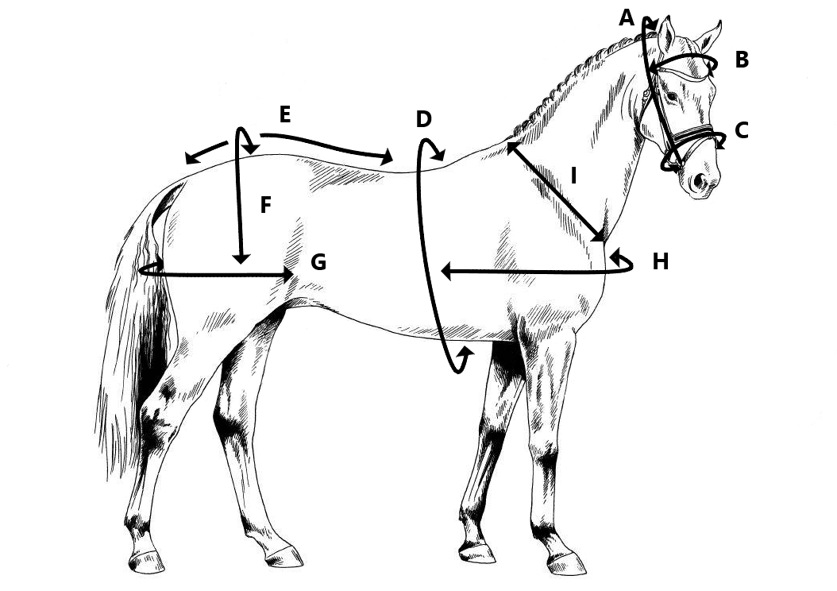

Breed of horse: ……………………………
Height of horse: …………………………… Hands
Weight of horse: …………………………… lbs
Type Harness: …………………………… Colour: …………………………..
 | What to measure: | How to measure: | Measurement:
A. | Bridle head | From corner of mouth to corner of mouth
B. | Brow band | From side of head to side of head
C. | Nose band | Circumference around the nose
D. | Girth | Circumference around the body
E. | Crupper | From back band to dock
F. | Loin | Over loin
G. | Breeching | From flank to flank
H. | Breast | From shoulder to shoulder
I. | Collar size | Width from wither to front of neck

