Harness Measurement Form

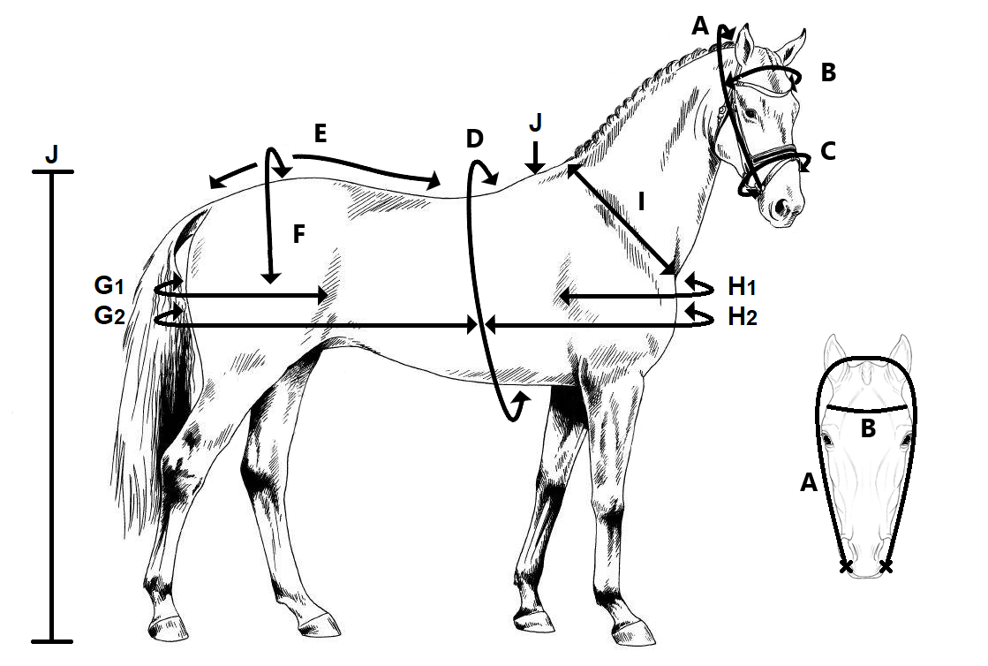
Name Customer: ……………………………
Date: …………………………..
Mail Adress: ……………………………
Breed of horse: …………………………
Type Harness: ………………………… Colour Harness: …………………………..
 | What to measure: | How to measure: | Measurement:
A. | Bridle head | From corner of mouth to corner of mouth
B. | Brow band | From side of head to side of head
C. | Nose band | Circumference around the nose
D. | Girth | Circumference around the body
E. | Crupper | From back band to dock
F. | Loin | Over loin
G1. | Breeching Single | From flank to flank
G2. | Breeching Pairs | From the middle of backpad flap around hindquarters tot he other side backpad flap
H1. | Breast Single | From shoulder to shoulder
H2. | Breast Pairs | From backpad around breast to backpad
I. | Collar size | Width from wither to front of neck
J. | Wither height | Height to wither

